 |  |  | What are NAFR priorities?  NAFR promotes:  - Better retirement income security policies  - A comprehensive national seniors’ strategy  - A Strategic framework to improve outcomes for veterans  - Universal pharmacare  What has NAFR done since its founding?  Thanks to your support, our interventions have resulted in several successes:  - 1973 –Constant lobbying by the Association resulted in the passage of legislation providing for full indexation of pensions.  - 1994 – The Association spearheaded the formation of the Seniors Coalition for Social Justice, which aims to ensure that any changes to seniors' income security programs are thoroughly reviewed.  - 2001 – The Association's advocacy initiatives led to the creation of the Pensioners' Dental Services Plan (PDSP); a dental plan provided to all federal retirees.  - 2018 – After several years of advocating for a dedicated seniors' voice in the federal government, the Association was pleased to see the creation of a new cabinet role: that of Minister of Seniors.  - 2022 – The Association's hard work at the bargaining table paid off, and Treasury Board approved the proposed PSHCP renewal agreement, which benefits all federal retirees.
  National Association of Federal Retirees – Outaouais Branch
  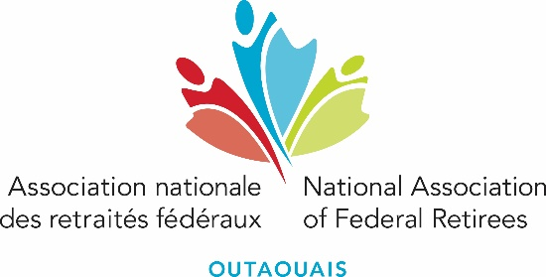
  Promoting retirees’ financial security, health, and well-being.
  Who are we?
  Founded in 1963, NAFR is the largest national, not-for-profit advocacy organization for serving and retired members of the federal public service, the Canadian Armed Forces, and the Royal Canadian Mounted Police, retired federally appointed judges, and their partners and survivors.
  With its 76 branches located across the country, the Association has more than 170,000 members. Its goals are to protect members' pensions and benefits and support policies that improve the lives of all Canadians in retirement. The Association works to improve the financial security, health and well-being of our members and all Canadians.

Why join NAFR Outaouais?  NAFR Outaouais is the association branch that has represented your interests as federal retirees in the region since 1992. Following the adoption of the Canadian Non-Profit Organization Act (NPO) in 2011, the branch joined the national NAFR body in 2016 to comply with the requirements of NPOs. With over 11,300 members (and still growing), the branch is your voice to national levels and local elected officials and works in partnership with other organizations representing seniors in the region to voice your concerns. NAFR Outaouais can refer you to expert practitioners about your rights as federal retirees.  Who can join NAFR Outaouais?  Federal retirees from the public service, the Canadian Forces, the RCMP, federally appointed public servants and court judges and their surviving spouses. Future retirees from these organizations can also join NAFR Outaouais.  How much does NAFR Outaouais membership cost?  Simple membership:  $4.90/month* or $58.80/year  Dual membership:  $6.37/month* or $76.44/year  * Source deductions recommended |  |  | Other advantages of joining NAFR Outaouais?  Preferred Partner Program  Monthly newsletter
  NAFR Outaouais membership offers you savings on a range of products and services with its national preferred partners, and other local discount programs. Consult the list on the NAFR website under our branch home page under “Local Preferred Partners”.
  We offer periodically The Latest News from the Branch bulletin that informs you about the branch’s events and activities.
  Webinars
  Expert speakers will inform you about various topics.
  Webinars - Federal Retirees
  Events
  Networking events (luncheons), barbeques, sugar shacks, the Christmas banquet and more. These events are offered in collaboration with our partners.
  Contact us
  115-331 Boul de la Cité-des-Jeunes,
  Gatineau, QC Canada, J8Y 6T3
  819-776-4128 / 1-888-776-4128
  admin@anrf-outaouais.ca

